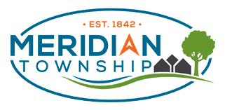
AGENDA
CHARTER TOWNSHIP OF MERIDIAN Lake Lansing Advisory Committee
June 13, 2023 5:30 PM

- CALL MEETING TO ORDER
- PUBLIC REMARKS
- APPROVAL OF AGENDA
- APPROVAL OF MAY MEETING MINUTES
- PROJECTS UPDATE
- SUMMER NEWSLETTER
- LAKE RELATED TOPICS PUBLICATION
- PARK MANAGER’S REPORT
- ADJOURNMENT

All comments limited to 3 minutes, unless prior approval for additional time for good cause is obtained from the Committee Chairman..

Individuals with disabilities requiring auxiliary aids or services should contact the Meridian Township Board by contacting: Township Manager Frank L. Walsh, 5151 Marsh Road, Okemos, MI 48864 or 517.853.4258 - Ten Day Notice is Required.
Meeting Location: 5151 Marsh Road, Okemos, Ml 48864 Township Hall (VIRTUAL MEETING)

Providing a safe and welcoming, sustainable, prime community.

